Driver Drowsiness Detection System

**Team members:**

N. Hemanth Srivathsav -2010030113

Peri Vishwanadha Sastry -2010030470

Abhiram Sharma -2010030523

Vinay Kumar -2010030469

**1. Abstract**

Due to the drowsiness of drivers, car accidents kill thousands of people worldwide every year. This fact clearly illustrates the need for a sleep sensor application to help prevent such accidents and ultimately save lives.

In this project, we aim to develop a driver drowsiness detection system that helps people by detecting drowsiness while driving the vehicle and it automatically alerts the person so that he can drive safely.

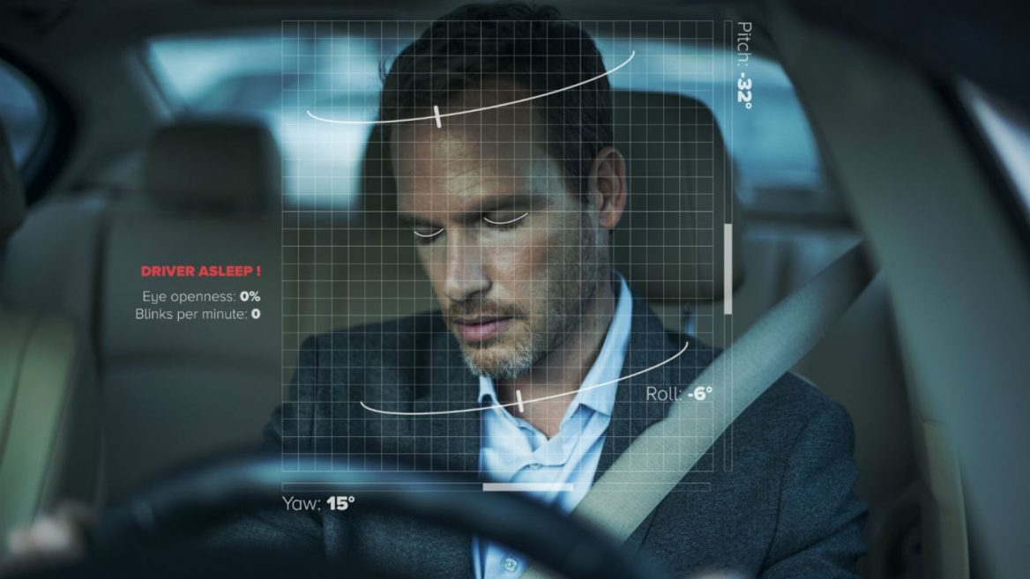

**2. Introduction**

Driver drowsiness detection is a car safety technology that prevents accidents when the driver is getting drowsy. Recent statistics estimate that annually 1,200 deaths and 76,000 injuries are happening because of the drowsiness of the people. The goal of this project is to create a model language recognition framework. The focus will be on developing a framework that can continuously monitor whether the driver's eyes are open or closed. It is widely recognized that driver fatigue can be detected early enough to avoid a car accident by looking at it. The detection of eye developments and flicker designs in an arrangement of pictures of a face is part of the exploration of fatigue.

Because of the hazard that drowsiness presents on the road, methods need to be developed for counteracting its effects. Driver inattention might be the result of a lack of alertness when driving due to driver drowsiness and distraction. Driver distraction occurs when an object or event draws a person’s attention away from the driving task. Unlike driver distraction, driver drowsiness involves no triggering event but, instead, is characterized by a progressive withdrawal of attention from the road and traffic demands. Both driver drowsiness and distraction, however, might have the same effects, i.e., decreased driving performance, longer reaction time, and an increased risk of crash involvement.

The development of technologies for detecting or preventing drowsiness at the wheel is a major challenge in the field of accident-avoidance systems.

**3. Literature review**

|  |  |  |  |  |  |
| --- | --- | --- | --- | --- | --- |
| S.no | Title | Authors | Publishing | Techniques & dataset | Pros |
| 1. | Driver Drowsiness Detection System and Techniques: A Review | Vandna Saini, Rekha Saini | International Journal of Computer Science and Information Technologies | ECG and EEG,  LBP (Local Binary pattern),  Steering Wheel Movement (SWM),  Optical Detection. | multiple categories of technologies are used |
| 2. | Driver-Drowsiness Detection System | S.Karthikeyana,  R.Subhab, G.Elakkiya | Turkish Journal of Computer and Mathematics Education | NTHU Drowsy Driver Detection Dataset. | This technique had an accuracy of more than 80% |
| 3. | Real-Time Driver-Drowsiness Detection System Using Facial Features | Ruoxue Wu | IEEE Access | CelebA ,  YawDD dataset | the average accuracy of this method is approximately 92% |

**4. Methods**

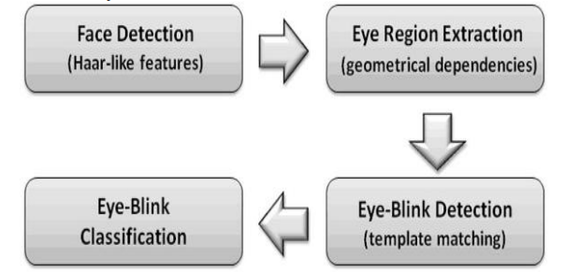

Visual object tracking is a crucial problem in computer vision. It has a wide range of applications in fields such as human-computer interaction, behavior recognition, robotics, and surveillance. Visual object tracking estimates the target position in each frame of the image sequence, given the initial state of the target in the previous frame

In this eye blinking rate and eye closure duration is measured to detect driver’s drowsiness. Because when driver felt sleepy at that time his/her eye blinking and gaze between eyelids are different from normal situations so they easily detect drowsiness.

**5. Results**

Several authors have proposed different approaches for Drowsiness detection system, most of them using ECG (Electrocardiogram), Vehicle Based approaches. A robust real- time embedded platform to monitor the loss of attention of the driver during day and night driving conditions.

We found some of the useful Techniques:

Steering Wheel Movement based Technique

Eye Blinking Based Technique

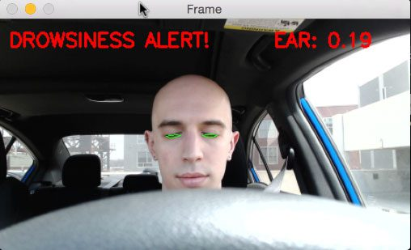

Yawning Based Technique

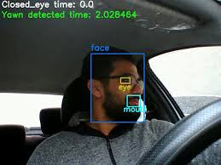

**DATASET:**

https://www.kaggle.com/dheerajperumandla/drowsiness-dataset

**6. Discussion**

This review paper describes the various methods for detecting driver's drowsiness by analyzing facial images taken by a camera.

This system involves two steps firstly the eye detection then detecting the drowsiness of the eye. Detection of the eye is done by the image processing technique.

In the second step we discuss various detection methods, the various movements of the \body etc.

Lack of proper light after sunset can cause problems in reading the images.

System detects the drivers eye wearing spectacles. In future implementation of the infrared light source could be a better solution for the lack of light after sunset.

**7. Conclusion**

As described throughout the paper, many technologies exist to detect driver fatigue. This paper tries to look at the emerging technologies and determine the best approaches in trying to prevent the number one cause of fatal vehicle crashes.

Currently, the number one selling product in the market is the market is nothing more than a reed switch to detect head angle tilt. This product is extremely limited and not very effective.

The product made by BMW and integrated into their high end cars to detect driver fatigue behaviour is slightly more effective is detection but lack proper notification to warn a driver.

The current market and technologies is in its infancy mode. New technologies keep emerging using different techniques.

Finally we would like to conclude that by designing a drowsiness detection system one would accurately determine the drowsiness level of a driver.

A number of road accidents might then be avoided if an alert is sent to a driver that is deemed drowsy.